64th Annual Conference
Leaders: Know the Way, Go the Way,
Show the Way
October 23-25, 2023
Huntington, West Virginia

Southern Regional Council on Educational Administration (SRCEA) is the only regional, non-profit organization for professionals in Educational Administration. The region is currently comprised of 14 states from Virginia in the northeast, to Missouri in the northwest, to Texas in the southwest, and to Florida in the southeast.
School principals, superintendents, professors, project coordinators, researchers, doctoral students, and other education professionals are invited to attend. The organization encourages collaboration across the region in terms of research and mentorship.
For More Information and to Register:
Registration Information
--------------------------------------------------------
CALL FOR PROPOSALS
Please submit the 2023 Proposal using the following Google Docs Form Link:

Conference Proposal

Proposals are due no later than 11:59 PM on September 15, 2023.

The Southern Regional Council for Educational Administration will host this year’s conference at Doubletree by Hilton 1001 3rd Avenue Huntington, WV 25701. 304.525.1001 (use code 918 to receive the special group rate).
You can also make reservations online by clicking the direct booking link for our group below:

Hotel Reservation

This year’s conference promises to be as exciting and learning filled as those in the past. We are blessed to have returned researchers and presenters as well as new colleagues and students. Be prepared to learn new research, hone your skills, and broaden your network of peers.
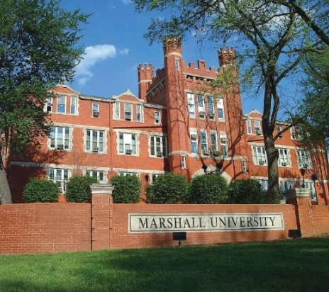
Beautiful downtown Huntington is the home of Marshall University whose campus is about a mile from the Doubletree. The student center is full of energy and a Starbucks, the football stadium is accessible for sports fans, and the new engineering department is worth the visit. We chose the Doubletree by Hilton because of Location, Location, Location. In addition to being a beautiful venue, it is within walking distance of Harris River Front Park, which offers a cool river breeze and a quiet atmosphere.

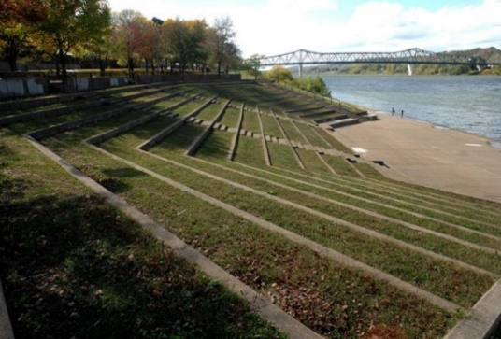
If you are more in the mood for shopping, eating, or the nightlife, you are in the right place.
Just a block away is Pullman Square Pullman Square | Shop. Dine. Explore. | Huntington, WV (pullman-square.com)

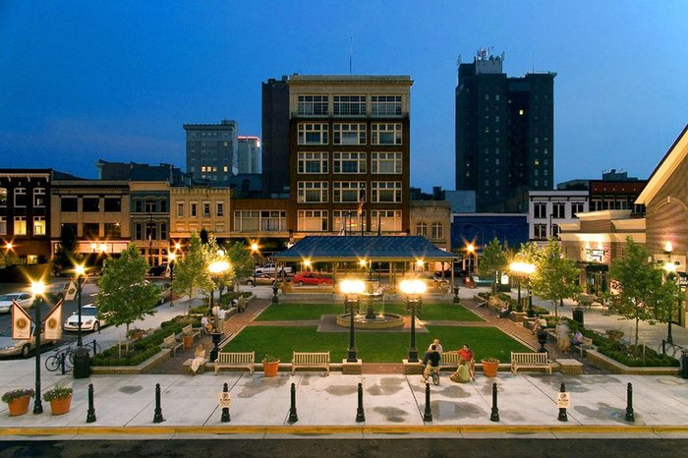
Pullman Square
Make sure you take the time to visit The Marshall Café for great food and a feel for the HERD community. In addition to Marshall Café, the Cellar Door offers a unique dining experience, as does The Market which hosts several shops and eateries. For certain you won’t go hungry here. Many of you will be happy to know Starbucks is close, as is Cold Stone Creamery; there’s something for everyone.

If you are feeling creative, you might try your hand at the Pottery Place or if you and your friends are up for adventure be sure to try the Escape Room.
I LOVE Huntington and want to show off its best. If you have any questions, please don’t hesitate to ask. – Eugenia Lambert, Conference Chair, webb24@marshall.edu

